**Institute of Engineering & Management**

**Department of Computer Science & Engineering**

**Communication Engineering Laboratory for 2nd year 4th semester 2018**

**Code: CS 491**

**Date:** 18/9/18

**ASSIGNMENT-1**

**Experiment Name: Sine wave in three different frequencies**

**Objective:** Generating three sine waves in three different frequencies and displaying it in DSO

**Theory:** A function generator is usually a piece of electronic test equipment or software used to generate different types of electrical waveforms over a wide range of frequencies. Some of the most common waveforms produced by the function generator are the sine, square, triangular and saw-tooth shapes.   
A digital storage oscilloscope (often abbreviated DSO) is an oscilloscope which stores and analyses the signal digitally rather than using analog techniques.   
A waveform is the shape and form of a signal such as a wave moving in a physical medium or an abstract representation. Here we are working with three waveforms mainly sine wave, square wave, and triangular wave.  
A sine wave or sinusoid is a mathematical curve that describes a smooth repetitive oscillation.   
We are generating these three waveforms using function generator and displaying them in the DSO (Digital Storage Oscilloscope) for different frequencies.

**Observation Table:**

**Sine Wave:**

|  |  |
| --- | --- |
| Function Generator | Oscilloscope |

|  |  |  |  |  |
| --- | --- | --- | --- | --- |
| Frequency | Volt(V) | frequency | Vpp(V) | Vp(V) |
|  |  |  |  |  |
|  |  |  |  |
|  |  |  |  |
|  |  |  |  |  |
|  |  |  |  |
|  |  |  |  |
|  |  |  |  |  |
|  |  |  |  |
|  |  |  |  |

**Waveforms:**

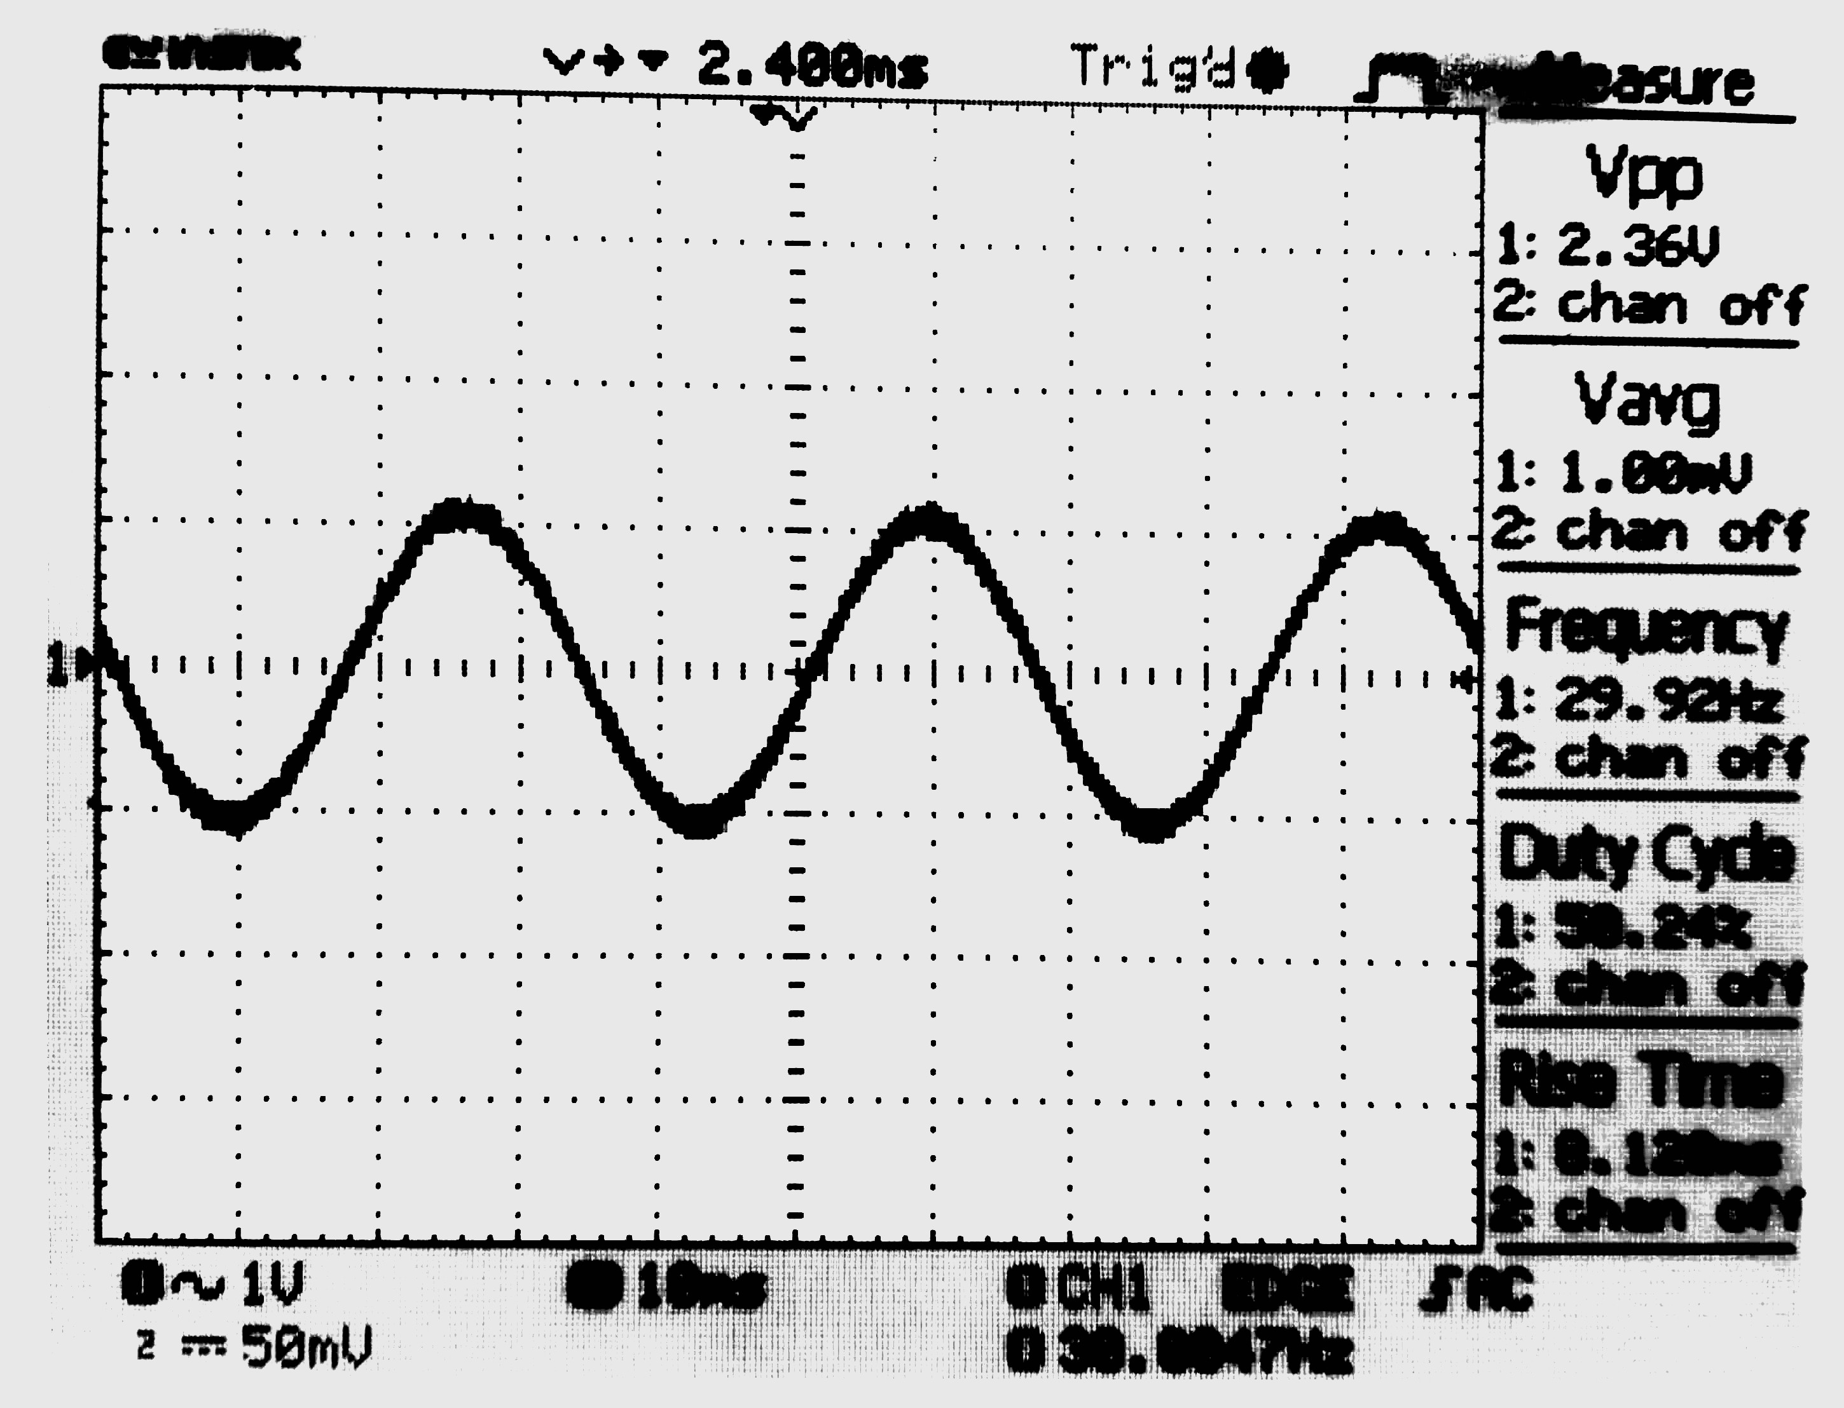

Sine wave

**Discussion:** From this experiment we learned how to use a function generator to generate sine waves of different frequencies and amplitudes and also how to display the wave in DSO